**Ch5-HSD-ManyMany**

**Homework:** Chapter 5 Heather Sweeney Designs Many-to-Many (N:M) Relationship (15 points) - Due ___ ___ __ Before Class

* Note: The Heather Sweeney (HSD) lessons, tutorials, and assignments use a simpler/older version than shown in the current textbook. The most significant difference is the identifier of the CONTACT entity.

**Many-to-Many (N:M) Relationship:** Create a relational database design from the following data model:

* This includes the CUSTOMER, SEMINAR, and CONTACT entities and relationships in the E-R diagram from assignment Ch4-HSDProject.

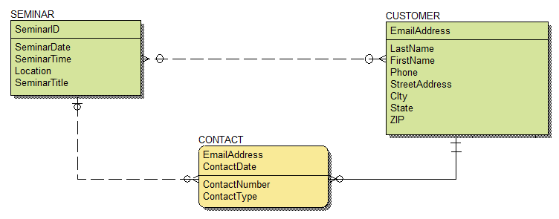

**Database Design:** (5 points)

* Write the definitions of the tables using the format TABLE (Column1, Column2, ...).
* Underline the primary key in each table, and italicize the foreign keys.
* Write the referential integrity check for each foreign key.

**HSD Database:** (5 points) Add the following to your HSD.accdb Access database:

* Create the SEMINAR table, the intersection table needed to link the SEMINAR and CUSTOMER tables, and the CONTACT table.
* Create the primary and foreign keys in each table, and the relationships between the tables.
* Add at least three rows of data in each table.
* You may use either the Access GUI or SQL for any parts of the database.

**SQL and QBE Queries:** (5 points) Create the following SQL and QBE queries in your HSD.accdb Access database:

* **SQLQuery-D and QBEQuery-D:** Write an SQL query to display all the seminar and customer information for each seminar (but not the contacts), by joining the SEMINAR and CUSTOMER tables.
* **SQLQuery-E and QBEQuery-E:** Write an SQL query to display all the contact and customer information (but not the seminars), by joining the CONTACT and CUSTOMER tables.
* **SQLQuery-F and QBEQuery-F:** Write an SQL query to display all the seminar and contact information (but not the customers), by joining the SEMINAR and CONTACT tables.